 

**Placement Empowerment Program**

***Cloud Computing and DevOps Centre***

**DAY 8 TASK**:

Set up a virtual machine in cloud create in aws, azure or gcp console. Launch a Virtual Machine and SSH into it

Name:SHAHANA.M.S Department: ADS



**Introduction**

Virtual Machines (VMs) are essential components of cloud computing, providing scalable, on-demand computing resources. Cloud platforms like AWS, Azure, and Google Cloud Platform (GCP) offer easy-to-deploy VMs that allow users to run applications, host services, and test environments without managing physical hardware. Setting up a VM in the cloud enables flexibility, cost efficiency, and ease of access from anywhere.

**Objective**

* To create and configure a Virtual Machine on AWS, Azure, or GCP.
* To understand the provisioning of compute resources in the cloud.
* To establish a secure connection to the VM using SSH.
* To explore cloud-based virtualization and remote server management.

**Importance**

* **Scalability**: VMs can be scaled up or down based on workload requirements.
* **Cost Efficiency**: Pay-as-you-go pricing ensures cost optimization.
* **Accessibility**: VMs can be accessed securely from anywhere via SSH.
* **Isolation & Security**: VMs provide isolated environments for running applications, ensuring security and reliability.
* Successfully launching a Virtual Machine on AWS, Azure, or GCP.

**STEP-BY-STEP OVERVIEW:**

Step 1: Go to AWS Management Console.

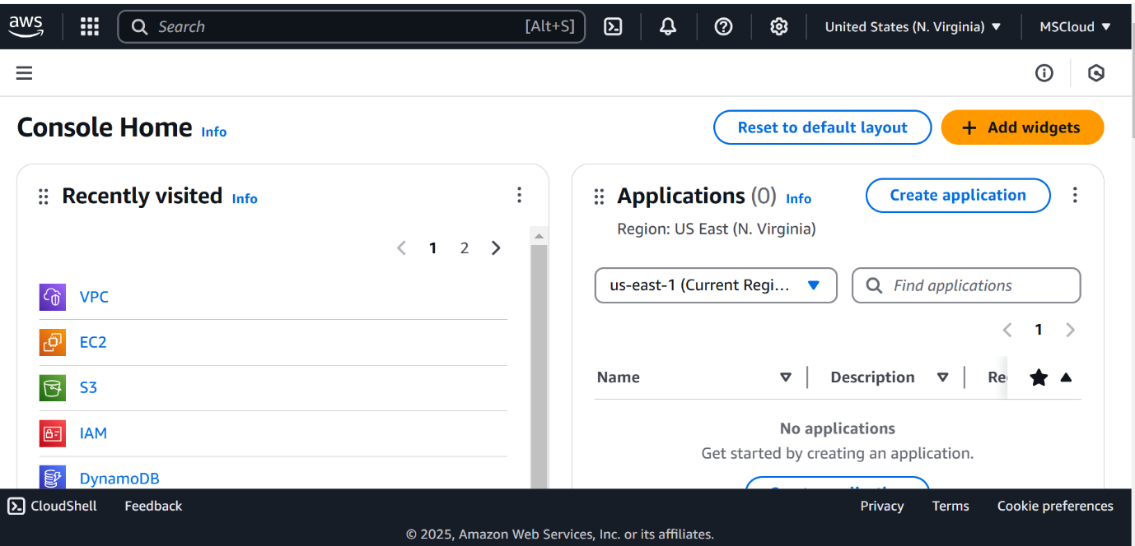

Step 2: Navigate to the AWS Management Console and search for EC2.

Step 3: Click Launch Instances.

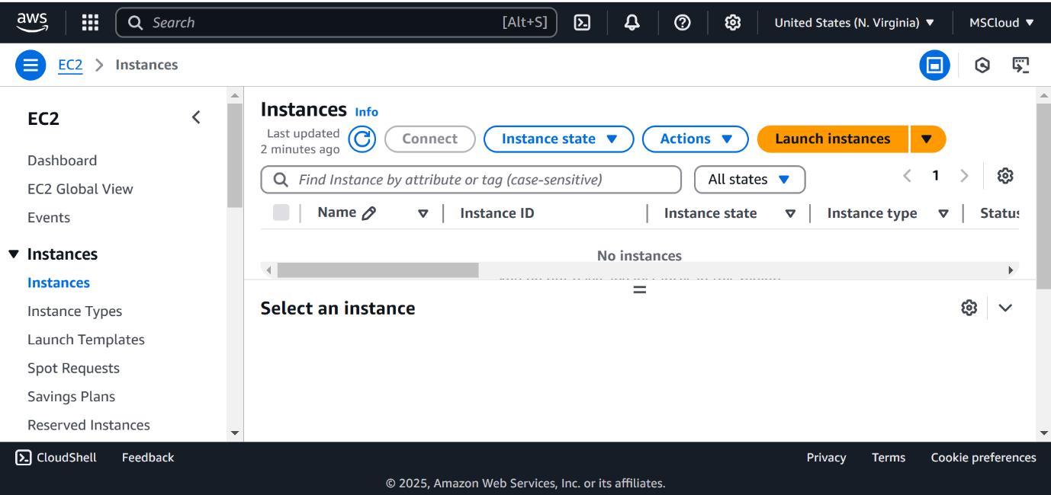

Step 4:

Now , select Ubuntu or Amazon, free tier t2.micro, and a subnet (in my case I have deleted a subnet so I should one and enter the IPV4 code ), then key pair select pem and create a new one or can also existing key pair saved as pem , then go permissions after clicking it you can copy SSN which is at the last of that page .

Step 5: Open PowerShell, navigate to the Downloads folder. Run the SSH command from the EC2 Connect section, replace the key name with your downloaded key (e.g., new.pem), press Enter, and type yes when prompted.

C:\Users\trust\Pictures\Screenshots\Screenshot 2025-02-05 225804.png

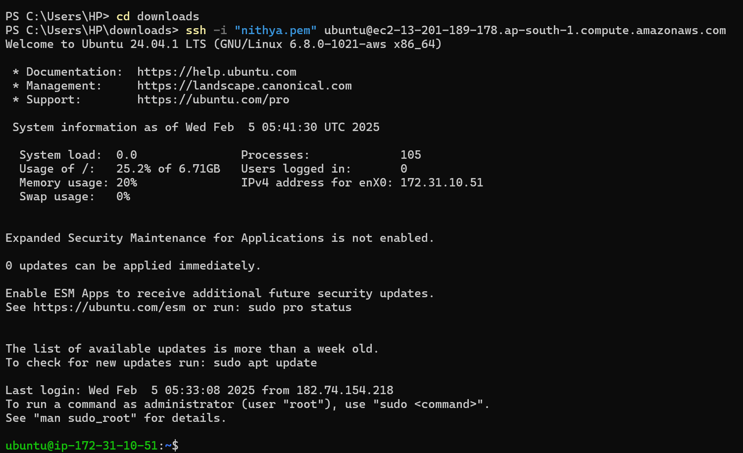

**OUTCOME:**

* Successfully launching a Virtual Machine on AWS, Azure, or GCP.
* Gaining experience in provisioning cloud-based compute instances.
* Establishing an SSH connection to securely manage the VM.
* Understanding key configurations like storage, networking, and security for cloud VMs.